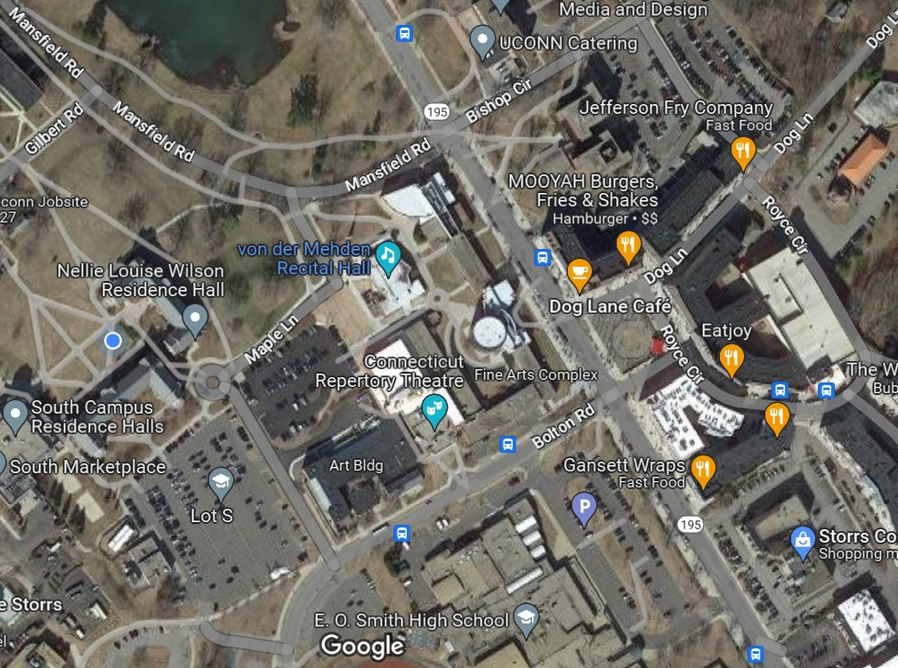Maple Lane and Coventry Road Closer on Friday 4/21/23 From 7am - 4pm

Road Closed Signage

Traffic Flows

